The platform for sales force is force.com

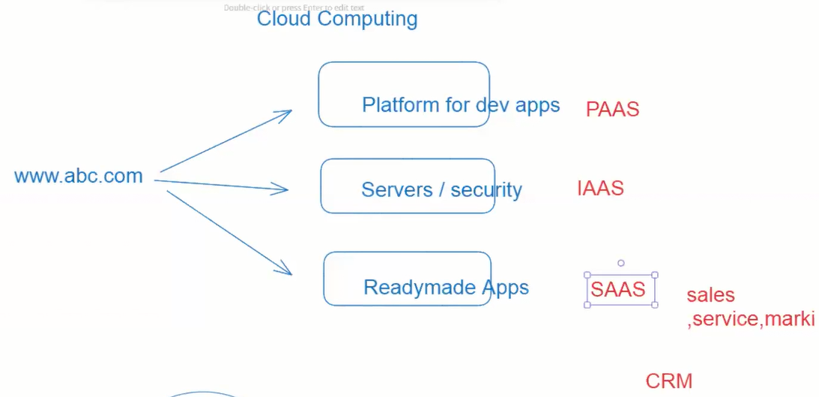  
Cloud computing will provide

SAAS software as a service

We can use but we cannot modify it

PAAS platform as a service

IAAS infrastructure as a service

SAAS will provide

Sales

Service

Marketing

CRM -Customer Relationship management

